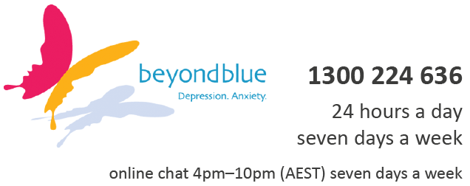
Helplines
youthbeyondblue Support Service
Call or chat online with a trained mental health professional.
We'll be there to listen, offer support and point you in the

right direction.

13 11 14
For urgent assistance call Lifeline which is a 24-hour telephone counselling service.
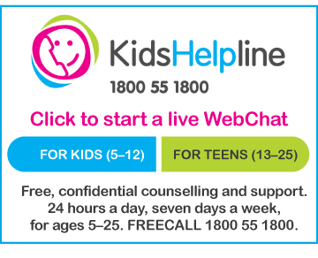
A free, private and confidential telephone and online counselling service specifically for young people between five and 25.
Free even from mobiles!

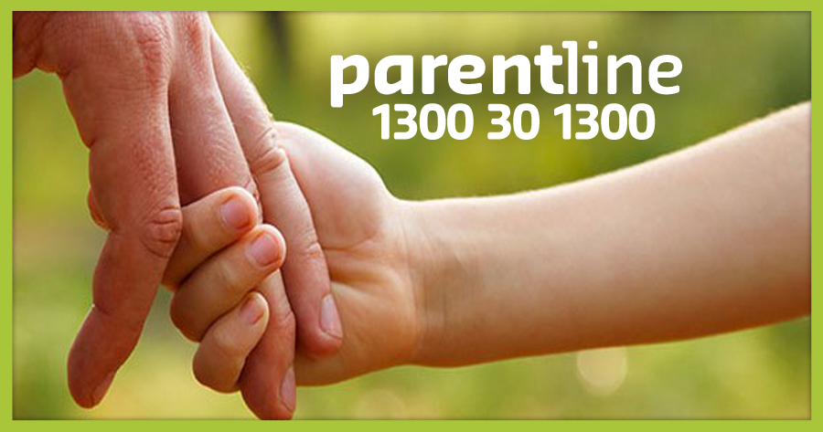
A confidential telephone service providing professional counselling and support for parents and carers of children in Queensland and the Northern Territory.

Call Parentline on 1300 30 1300, from 8am to 10pm, seven days a week for the cost of a local call.

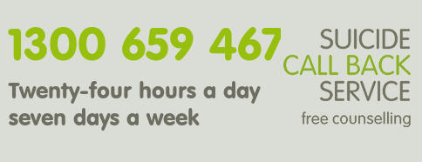
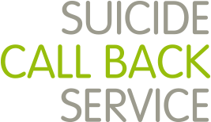

Suicide Call Back Service provides free phone, video & online counselling for anyone affected by suicide.
Get immediate help now by selecting one of our counselling services.

A leading provider of relationship support services for individuals families and communities. We aim to support all people in Australia to achieve positive and respectful relationships.
1 3300 364 277 Mon-Fri 8am-8pm / Sat 10am-4pm
DVConnect Womensline ph. 1800811811 is the only state wide telephone service offering women who are experiencing domestic or family violence 24 hours a day 7 days a week. We offer free, professional and non-judgemental telephone support to you, wherever you live in Queensland. We can arrange practical assistance such as counselling, intervention, transport and emergency accommodation for Queensland women and their children who are in danger from a violent partner or family member.


MensLine Australia is a professional telephone and online support and information service for Australian men 24/7

1800RESPECT is Australia’s national sexual assault, domestic and family violence support service. The service provides information, referrals and counselling 24 hours a day, every day of the year. If you or someone you know is impacted by sexual assault, domestic or family violence, call 1800RESPECT on 1800 737 732 or visit 1800RESPECT.org.au
Websites & Apps

iParent shows you how you protect your digital identity. Parents can learn about the digital environment and keep updated on their children’s technology use; find guidance for using safety settings on your family’s web-connected devices, tips for choosing movies and games and strategies for
keeping young people safe online.

Games, Apps and Social Networking Quick guide to popular social media sites and apps: Protect your yourself and your children.


headspace

Provides support to young people aged 12 to 25 who are going through a tough time, including anxiety, depression, bullying and body image.

eheadspace Internet chat, email or phone support for young people (12-25 years) with a range of issues. Call the helpline on 1800 650 890 REACHOUT.com Parents

Reliable information for parents about supporting young people’s mental health and wellbeing


Black Dog Institute Creating a mentally healthier world: The Black Dog Institute website has been designed to assist anyone seeking help or information about mental health and wellbeing.



GriefLine Grief helpline that provides telephone support services to individuals and families.


The BRAVE Program App: Online program to help you manage worry and anxiety. Includes up to 10 sessions that you can work through at your own pace. Comprises both youth and parent components.


MoodGYM App: A popular interactive program that teaches cognitive-behaviour therapy skills for preventing and coping with depression. Participation is free and anonymous.



The Smiling Mind App: Smiling Mind guides you through simple meditation exercises to get you started on your mindfulness journey. Colourful and warm, the app uses engaging illustrations and short meditation sessions to train you to become more aware of your breath and your senses, so you can bring mindfulness into your everyday routine.
ReachOut App: This online app can help young people who are going through a tough time to access the most appropriate support services for them, based on their own unique symptoms and experiences.

