
How to Add User Accounts to PC
- When logged in to the computer, click on the Windows icon and then the Settings wheel. | 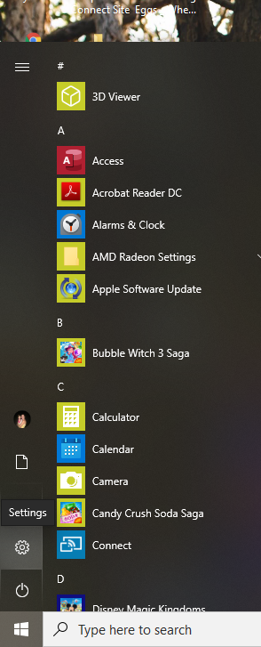
- Click on Accounts. | 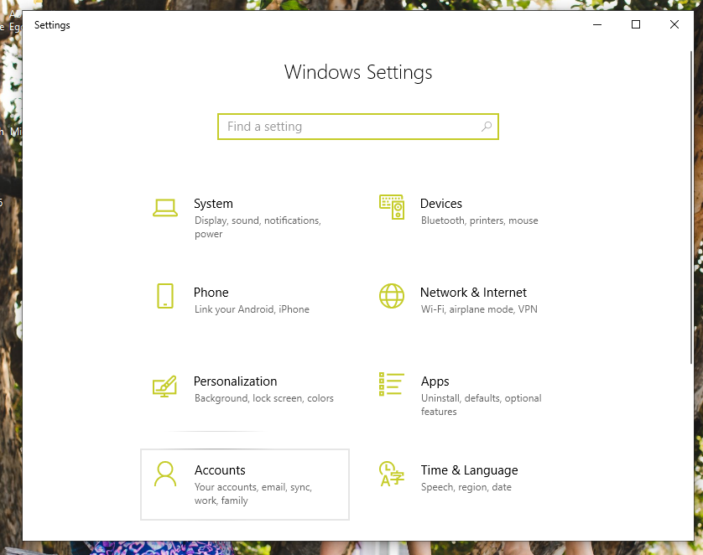
- Click on Family and other users | 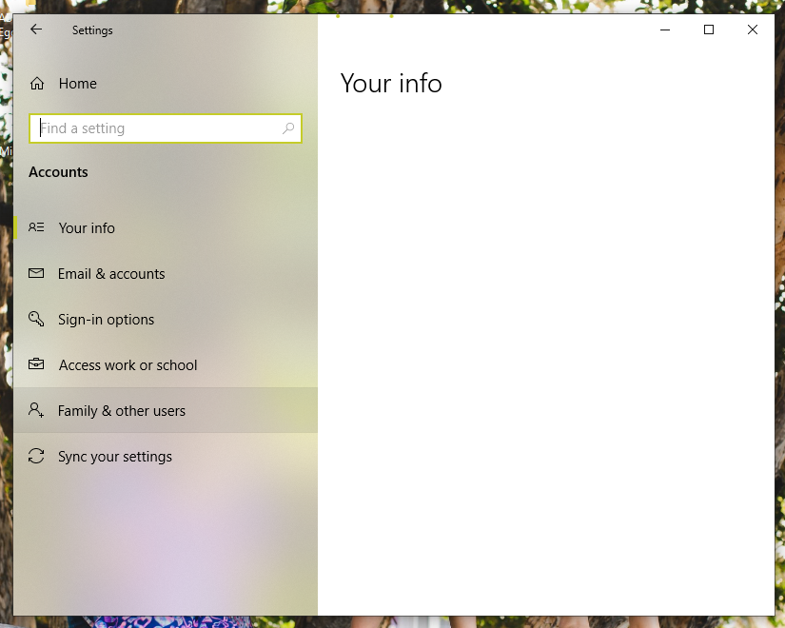
- Family and other users – Other users. Click on ‘Add someone else to this PC’. | 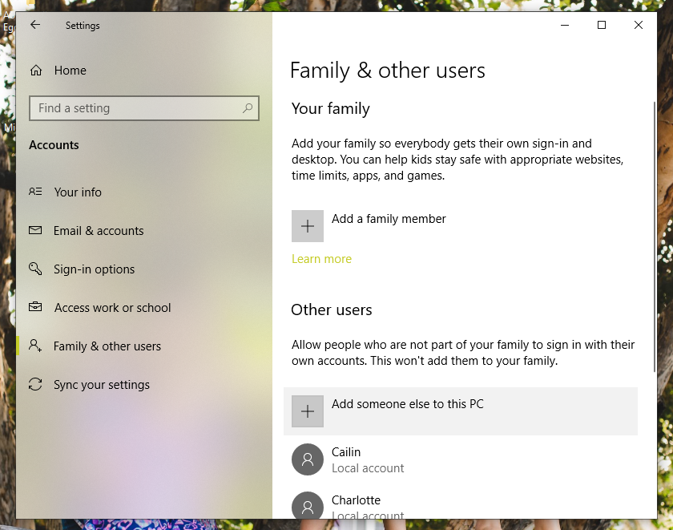
- How will this person sign in? Click on ‘I don’t have this person’s sign-in information’. | 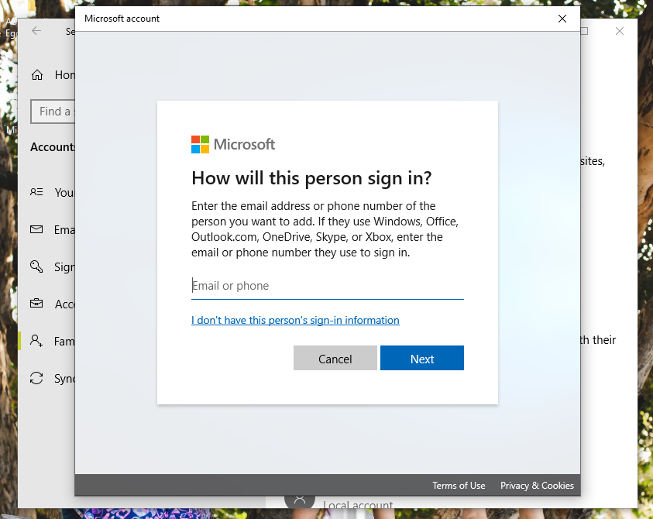
- Create account – click on ‘Add a user without a Microsoft account’. | 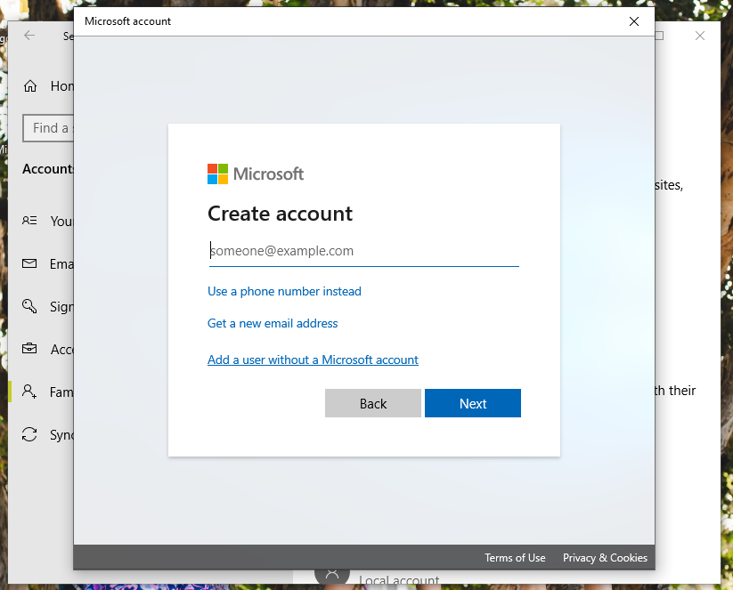
- Create an account for this PC – add the new username (student name) and a password. Create answers for security questions. | 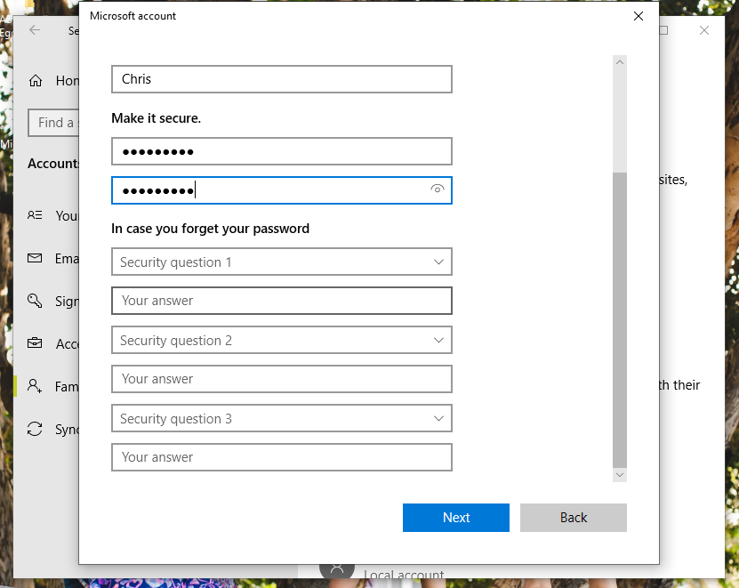
- The new user account will now be visible.  NOTE: Restart Computer - the new user account will be visible on the log in screen (bottom left corner). | 