
How to Open OneNote app from Browser
- Click ‘Open in app’ | 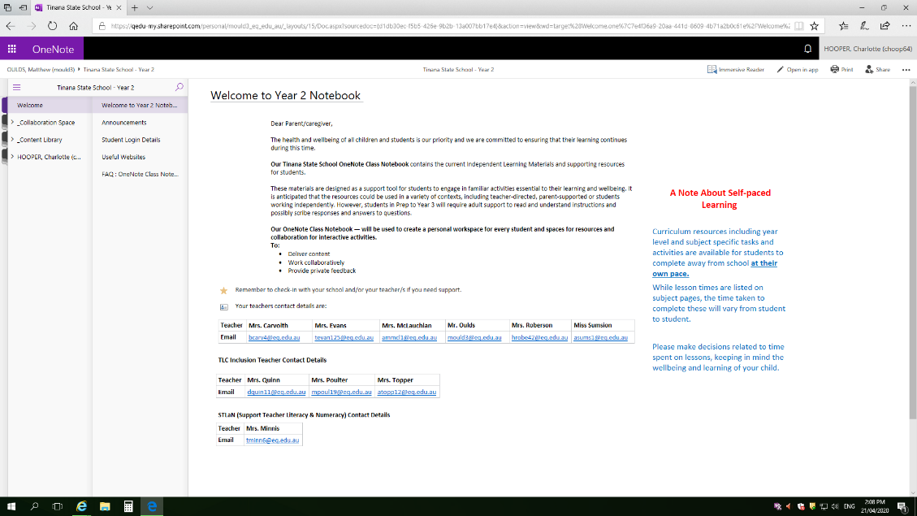
- Open in OneNote app 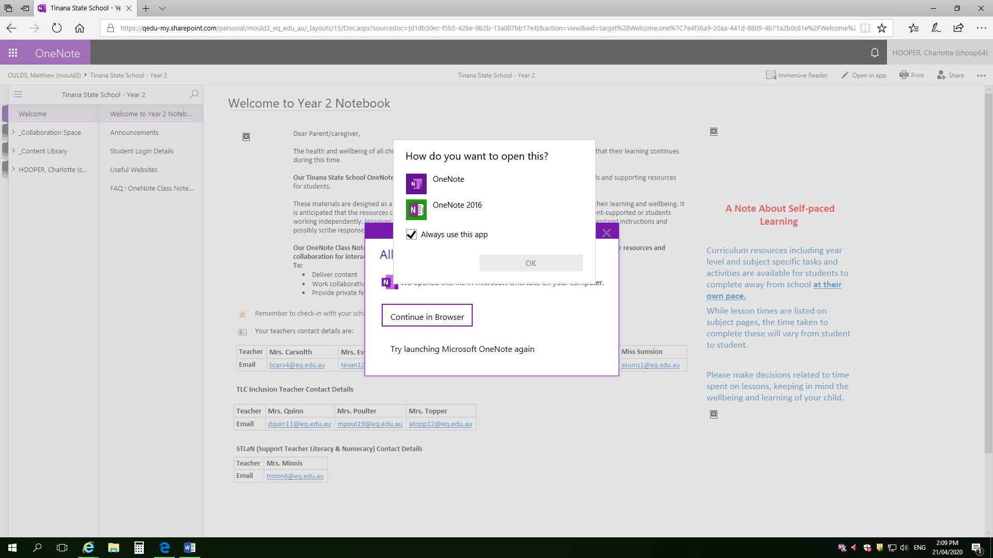
- Choose OneNote | 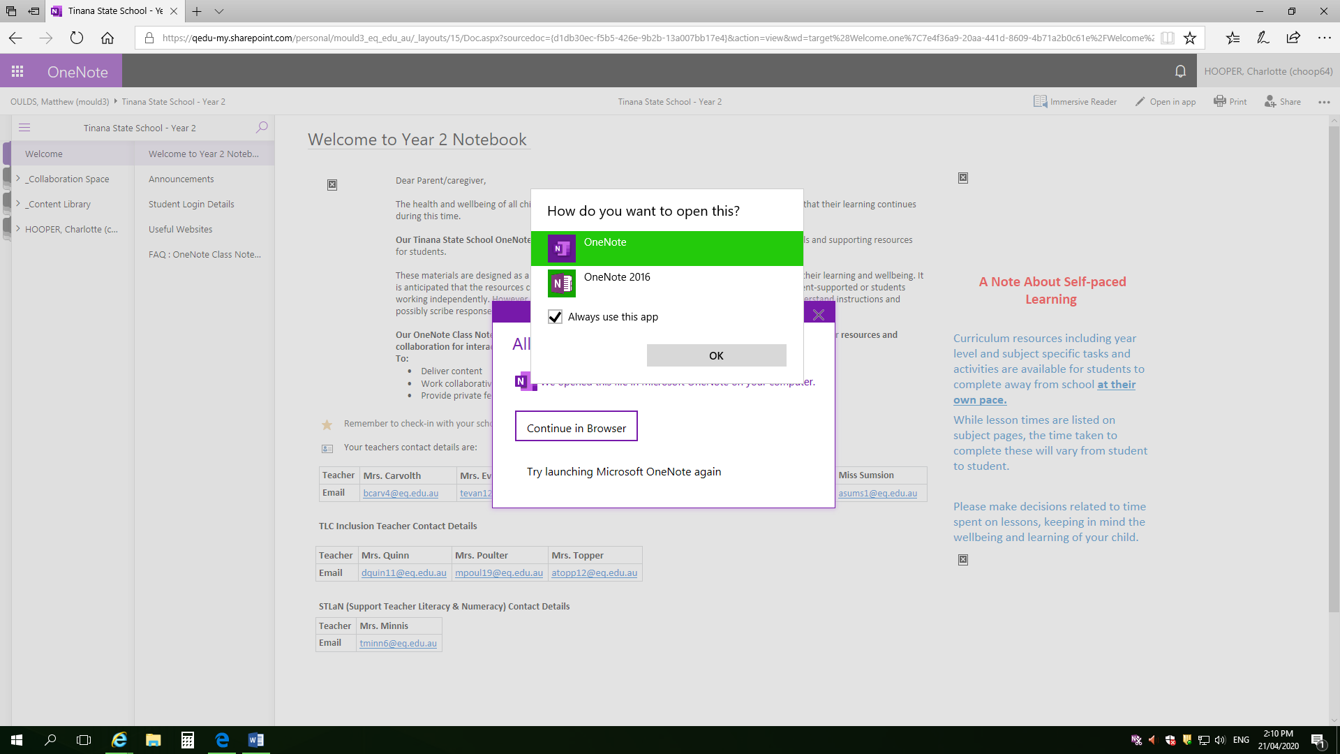
- Your screen will look like this while it is loading | 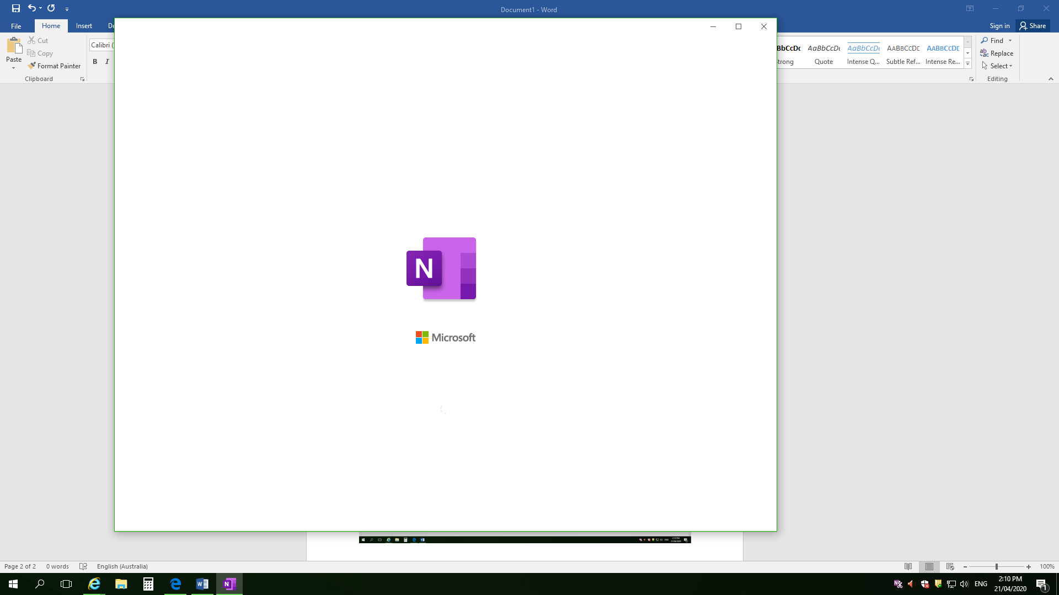
- This notebook should now be saving offline and you will see the Draw tab available | 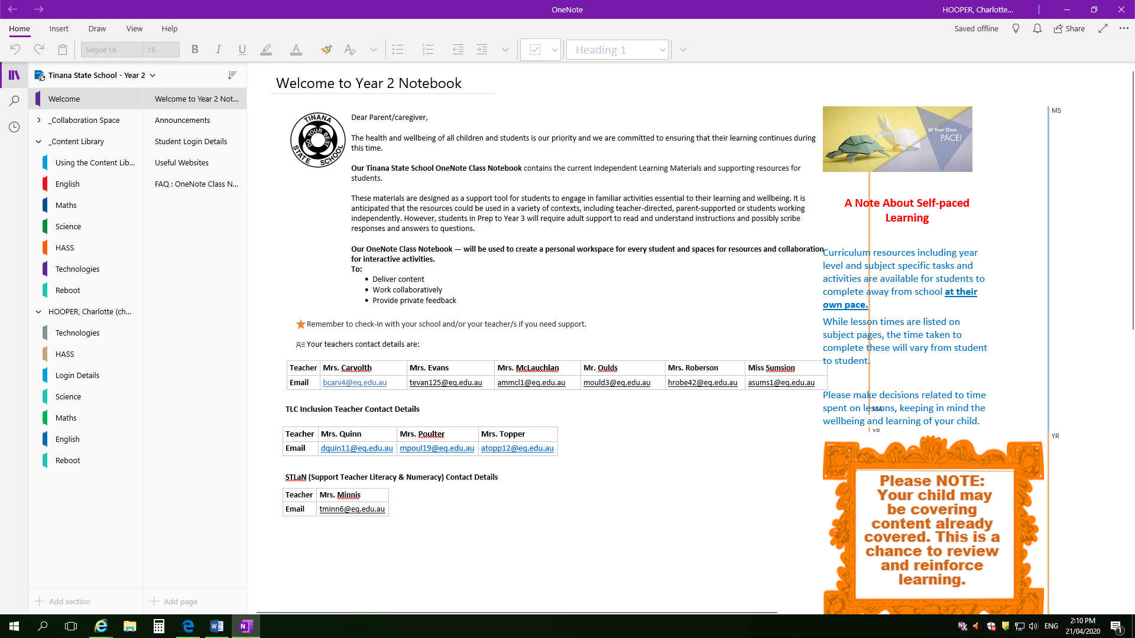
e.g. English Tab | 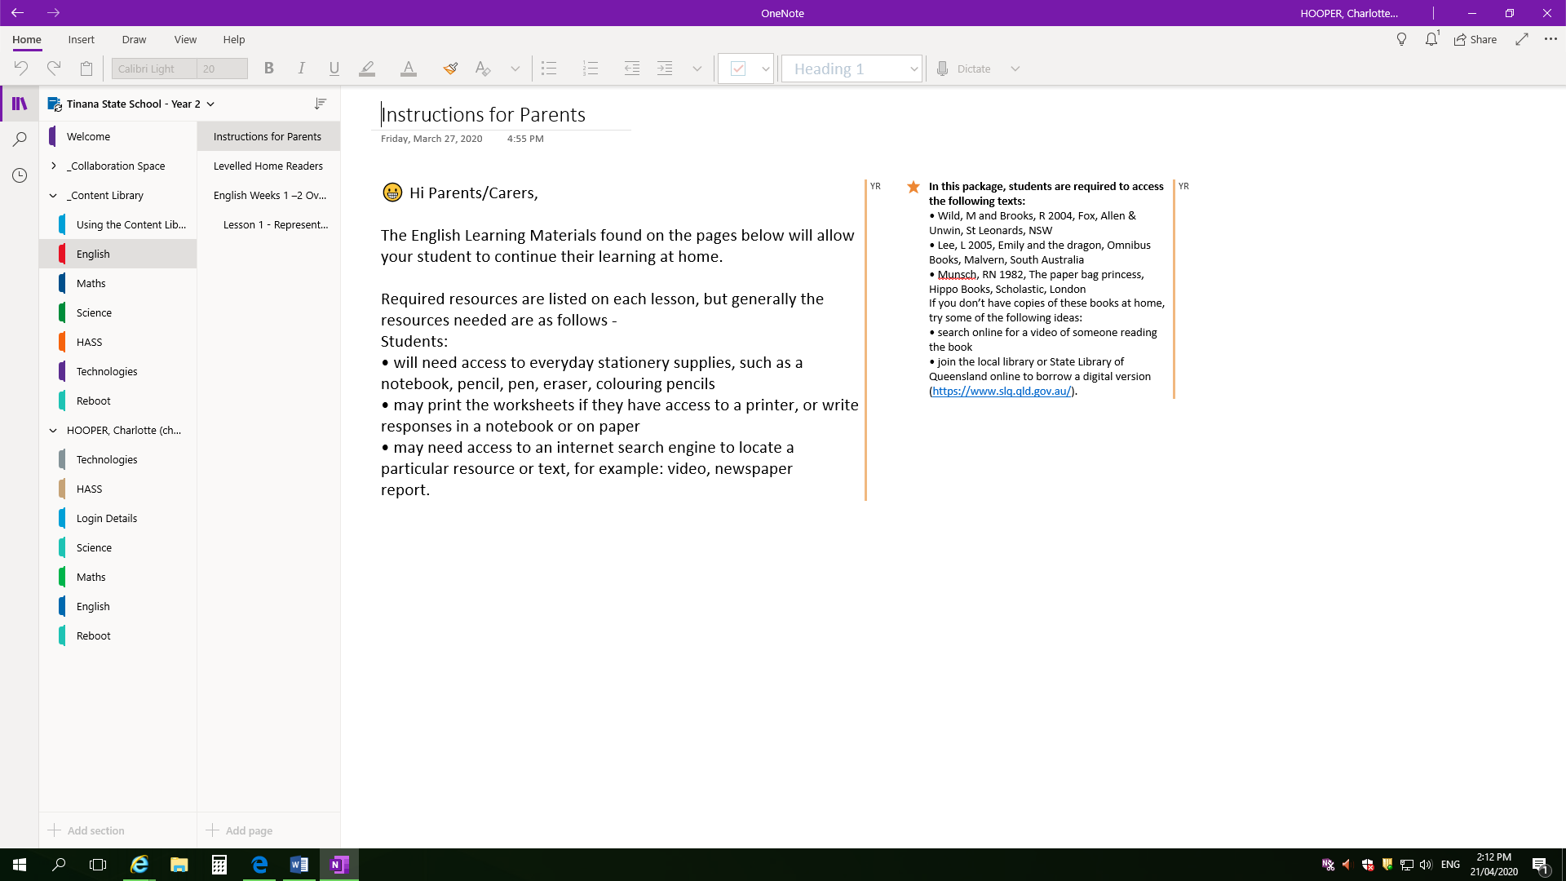
Where to next: (useful ‘TSS_How to…’ documents) | - How to Sync OneNote app.  - How to use Draw Tab in OneNote app.

