
How to sync in OneNote app
- Right click on Notebook name
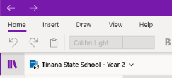
e.g.

- Left click on Sync
e.g.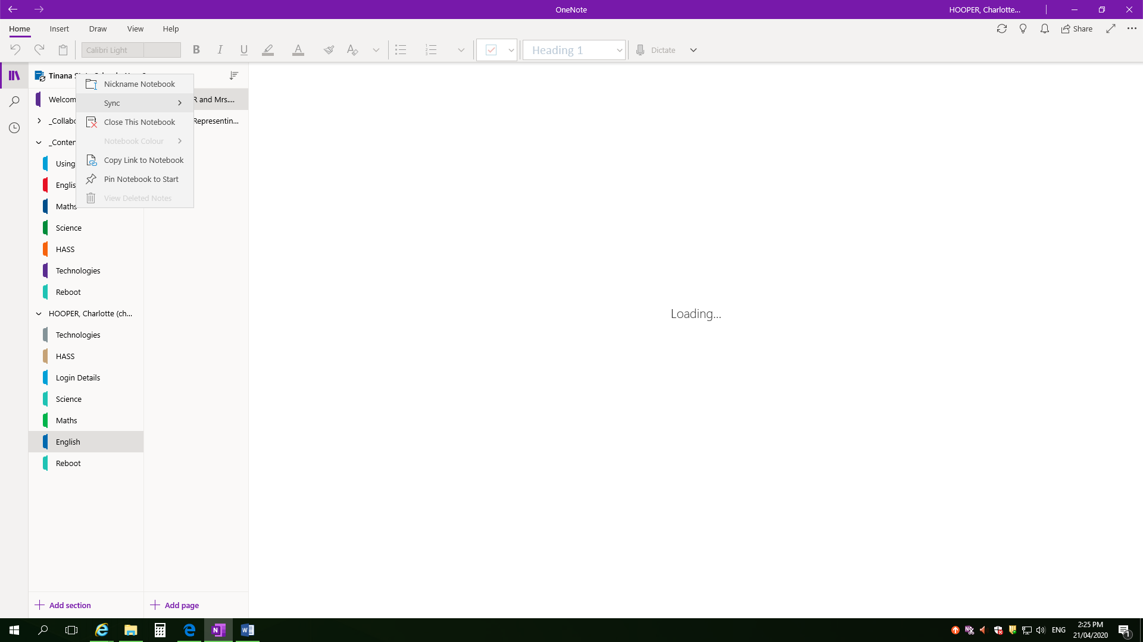
- Left click on ‘Sync This Notebook’
e.g.
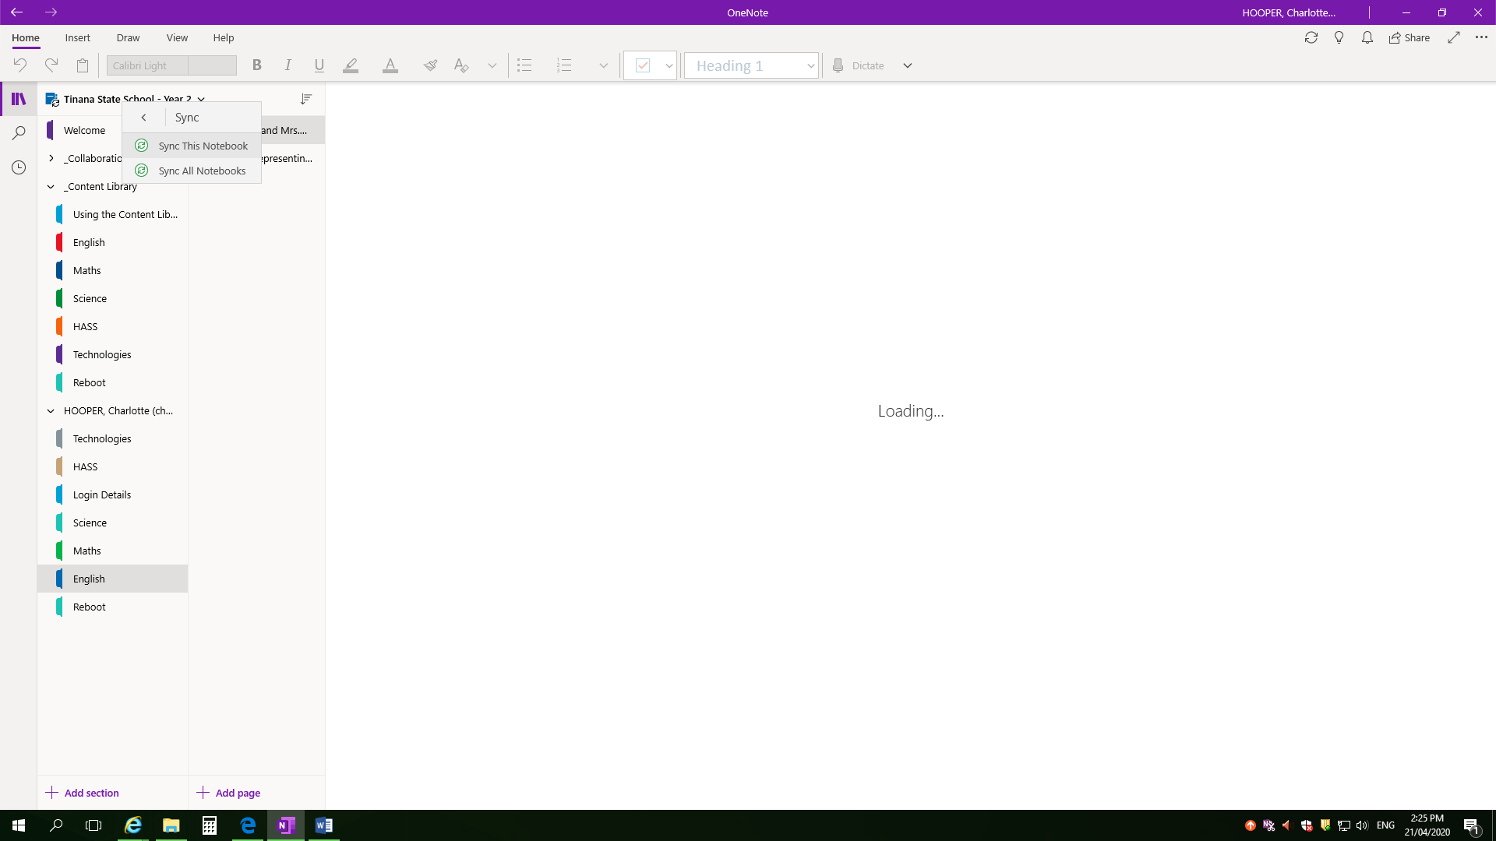

- Notebook will indicate below symbol 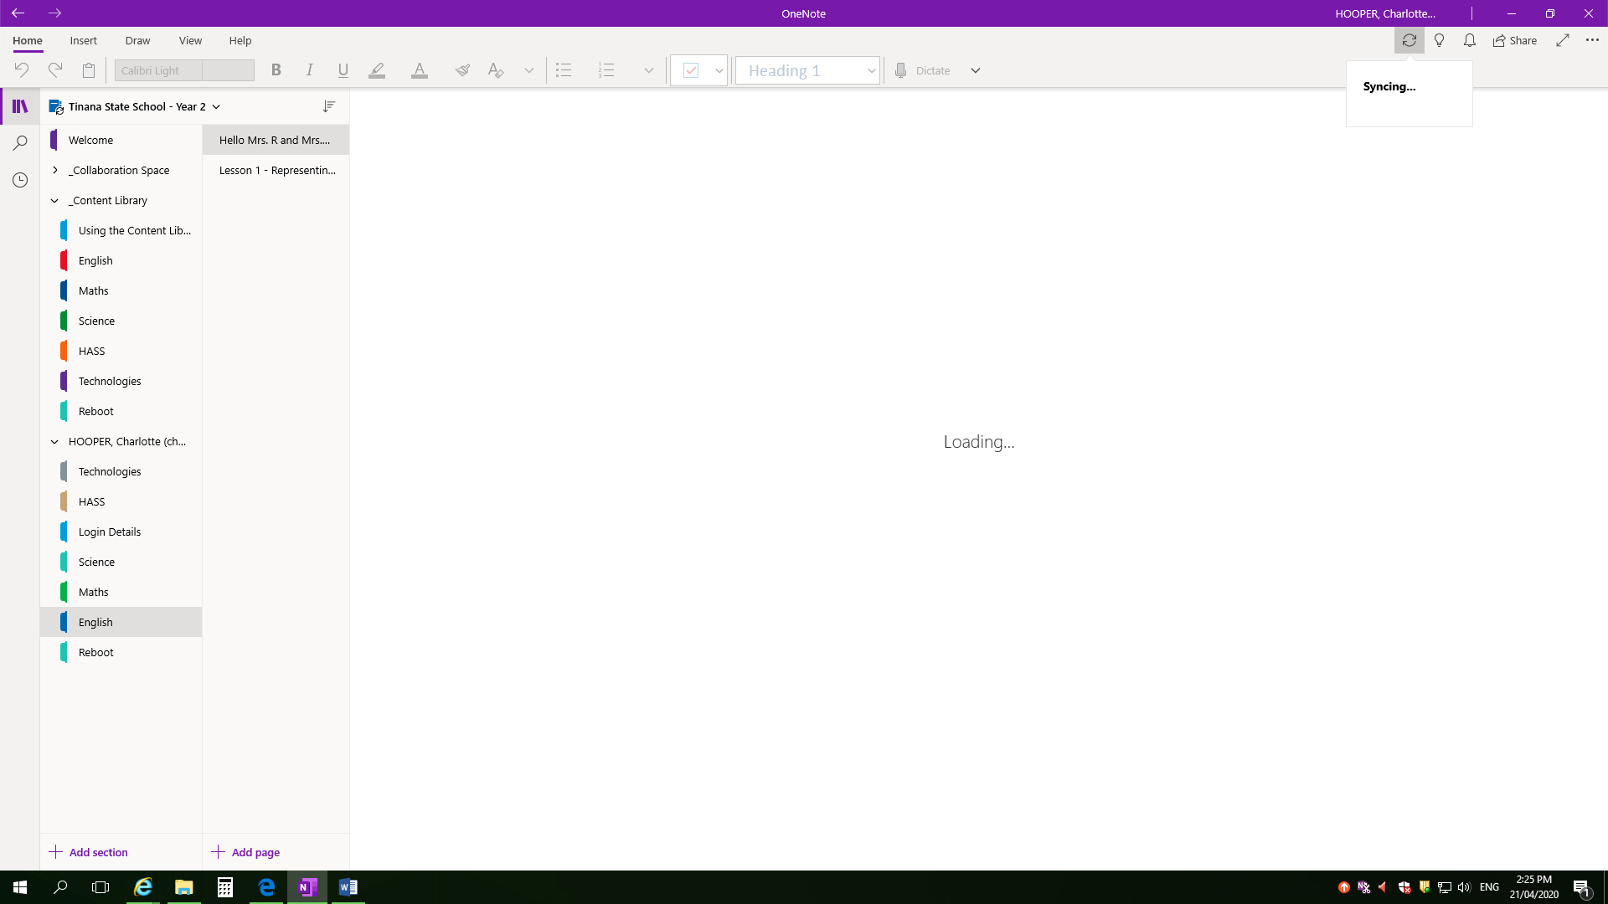 and display ‘Synching…’ message

- Do not sit and watch it load or it will not work HAHA! Kidding!  (…but seriously, go and have a break for 5 minutes). | 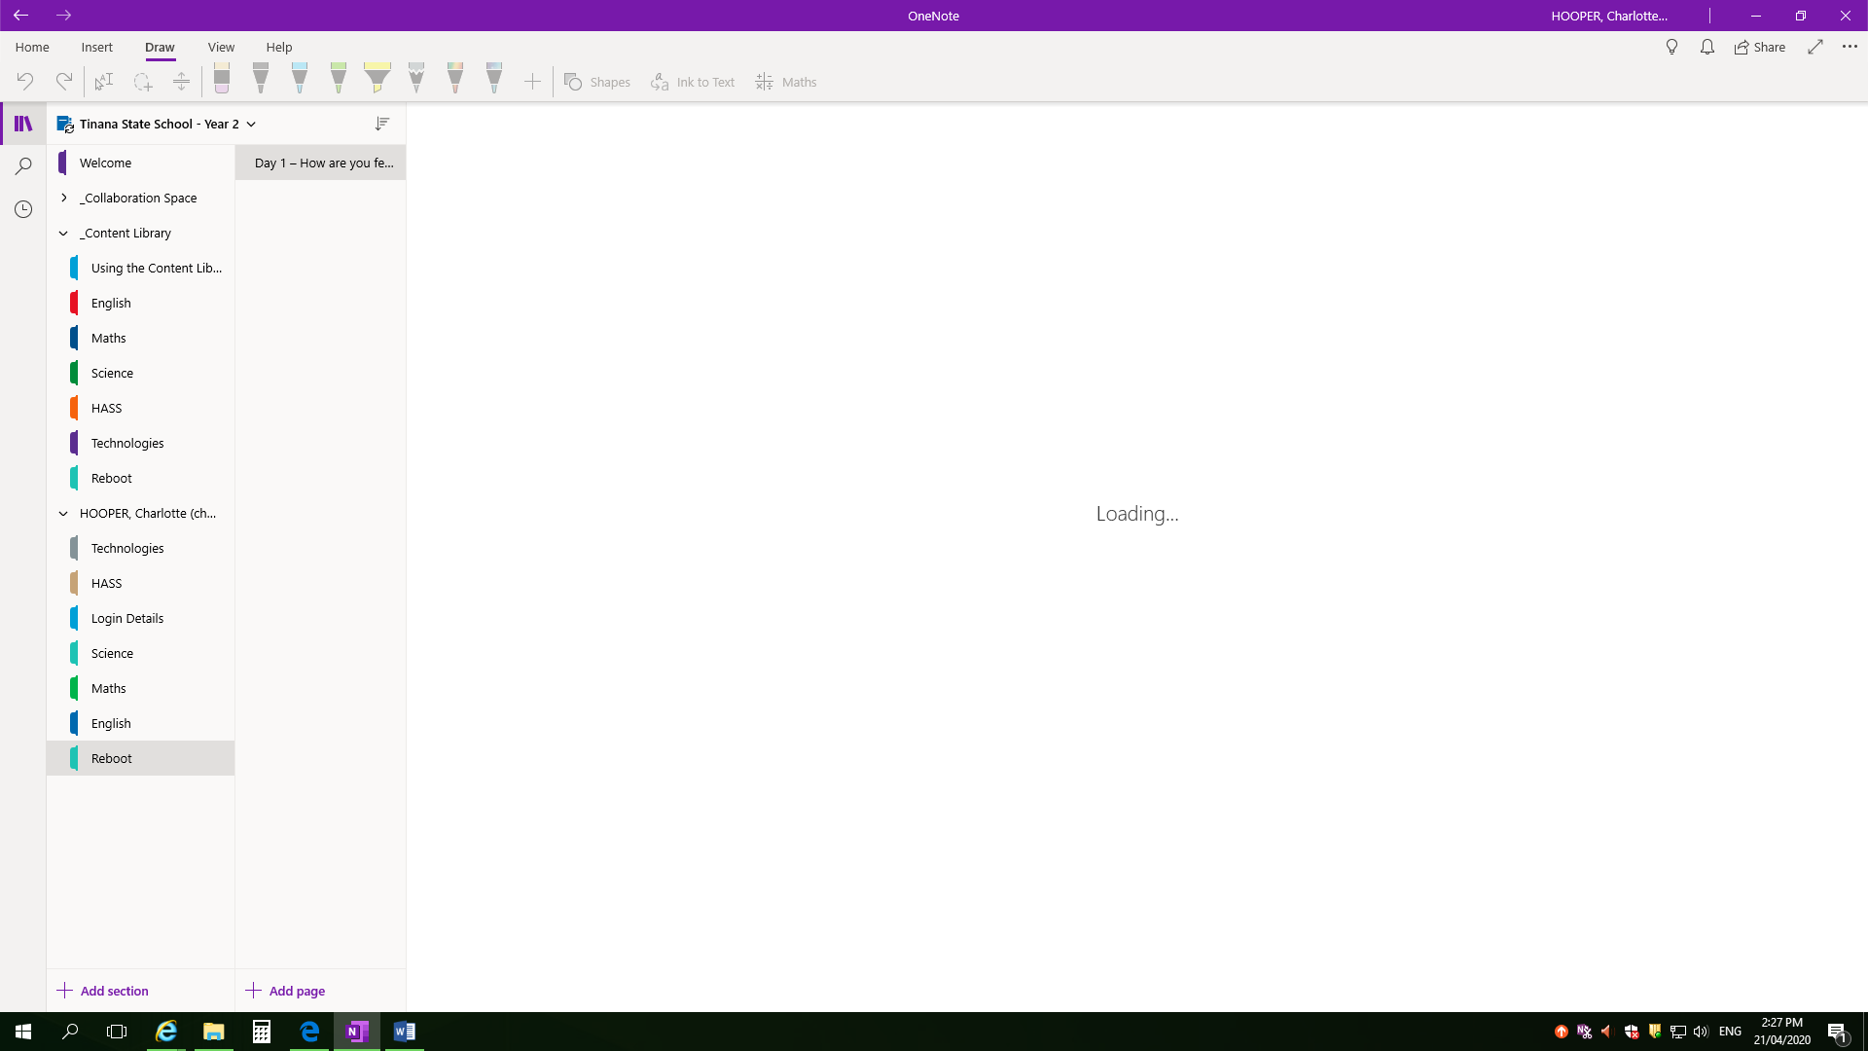
Saved offline (error)  - Click on ‘Saved offline (error)’ | 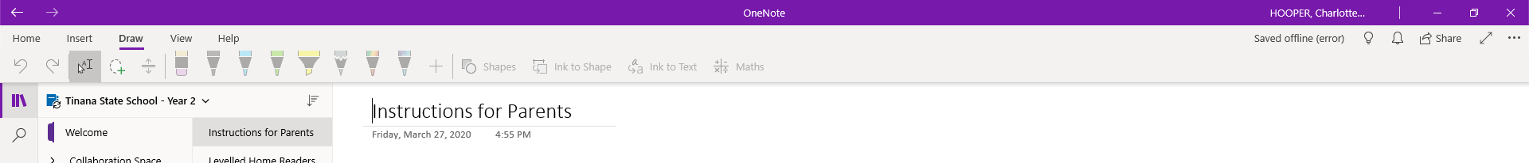
- Left click ‘Sync now’ button 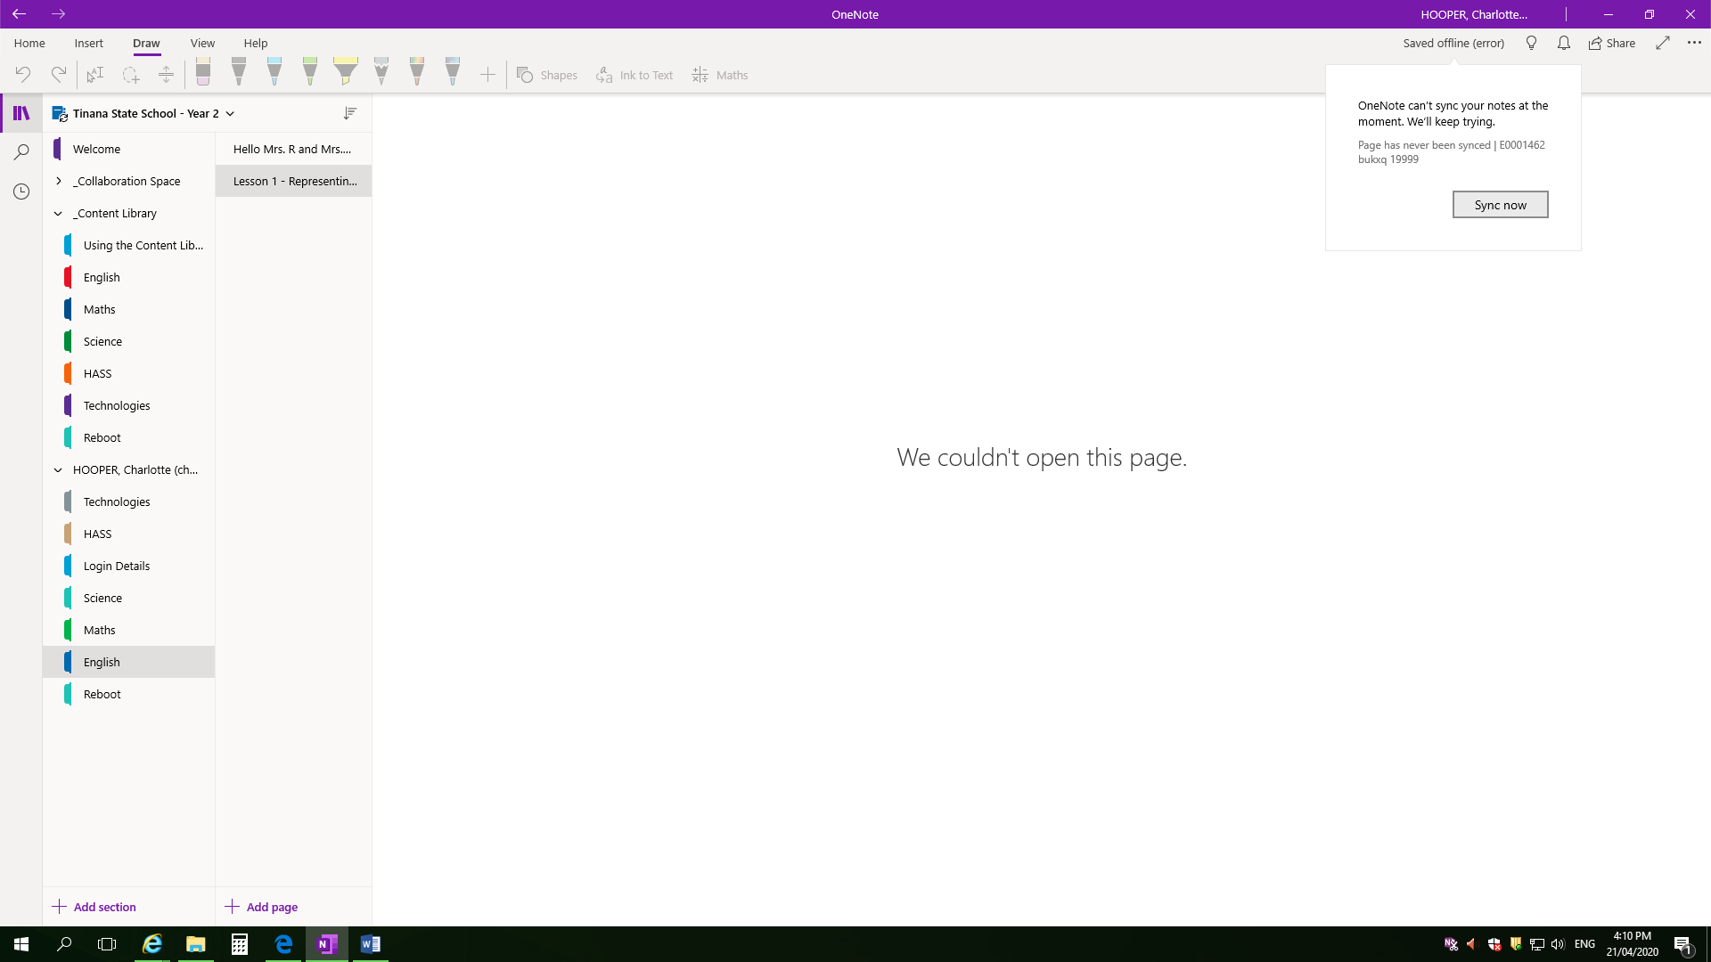
- Go back into browser app and click ‘Continue in Browser’ to sync new content or Try launching Microsoft OneNote again. | 