
How to use the Draw tab in OneNote
- You will see that you now have access to the draw tab and tools. Select Draw Tab. 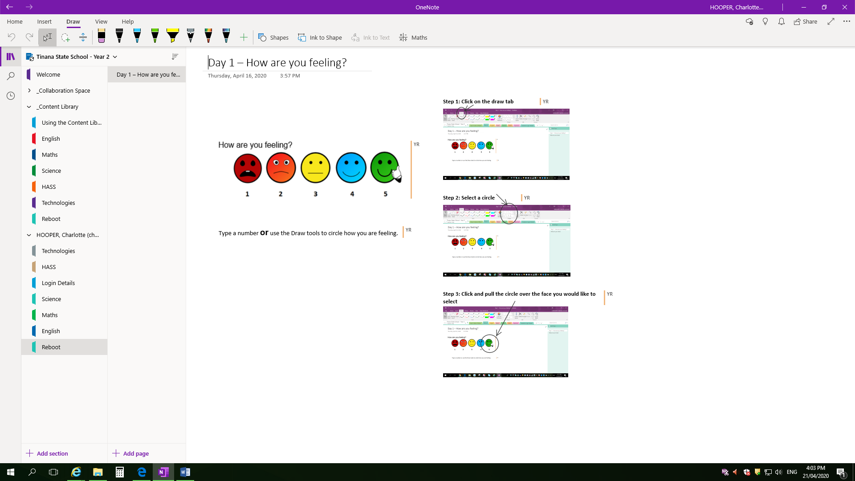

- Select pen type
e.g.
- Select Colour
e.g. 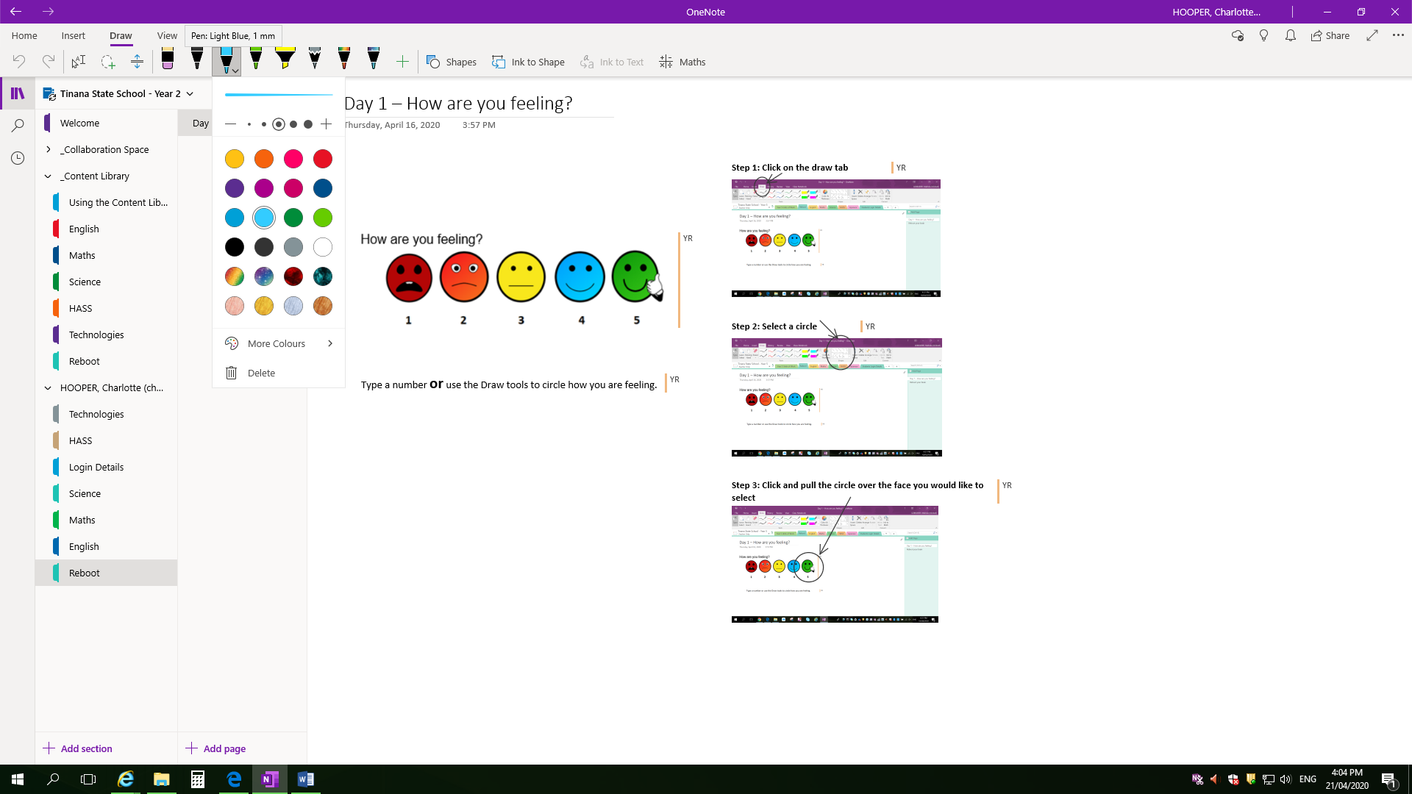
- Choose width
e.g. 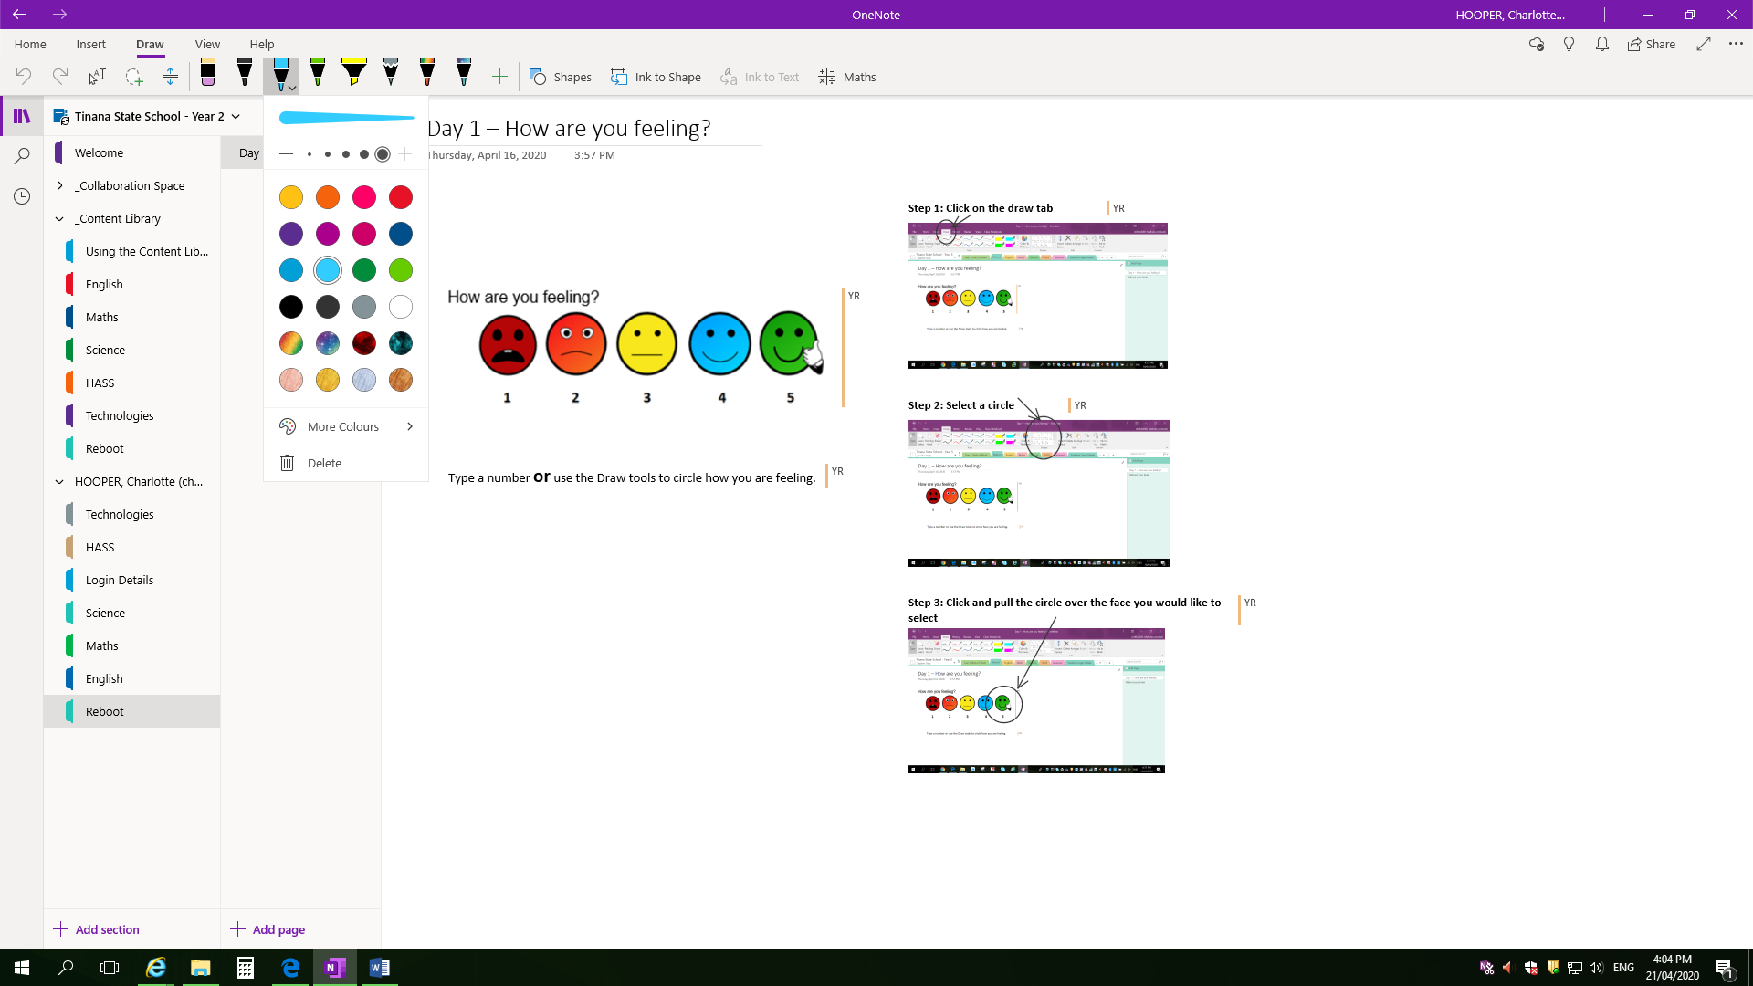
- Left click and drag on Pen to draw | 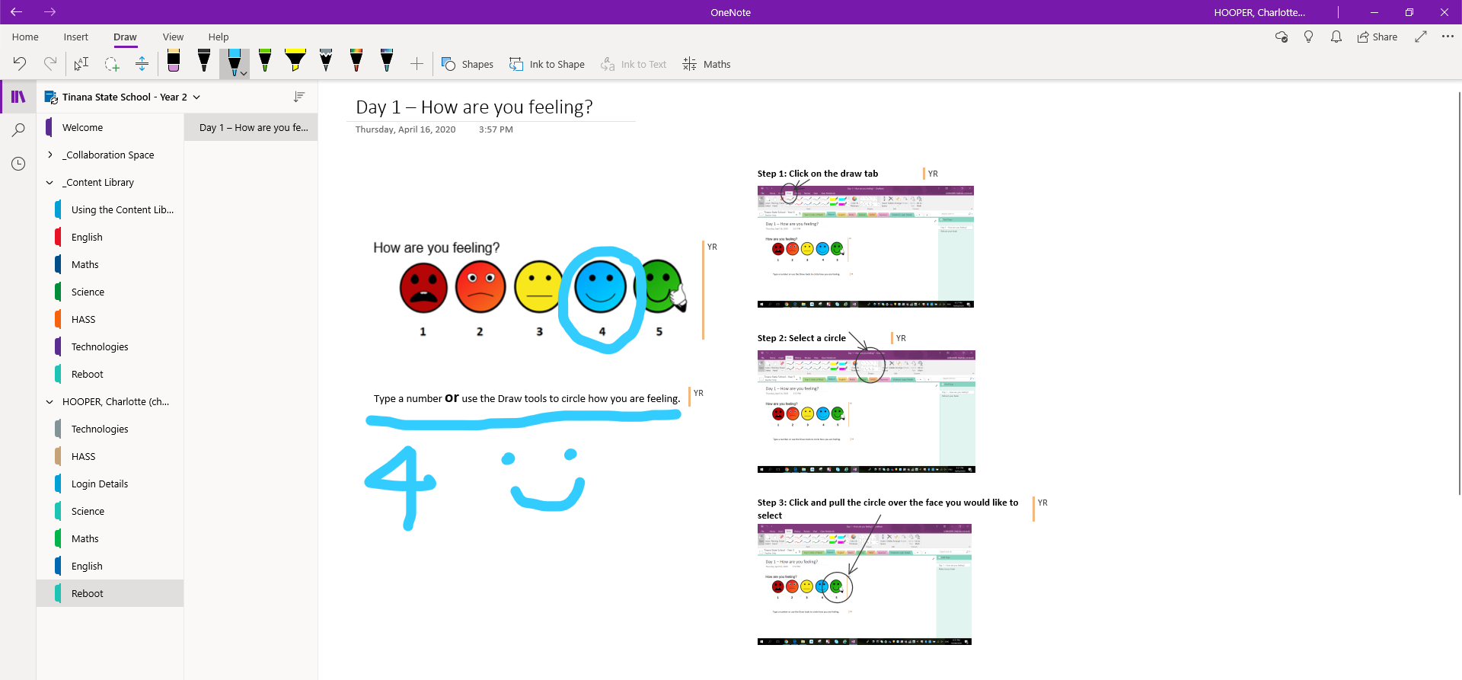
- Insert a Shape. Left click on ‘Shapes’ button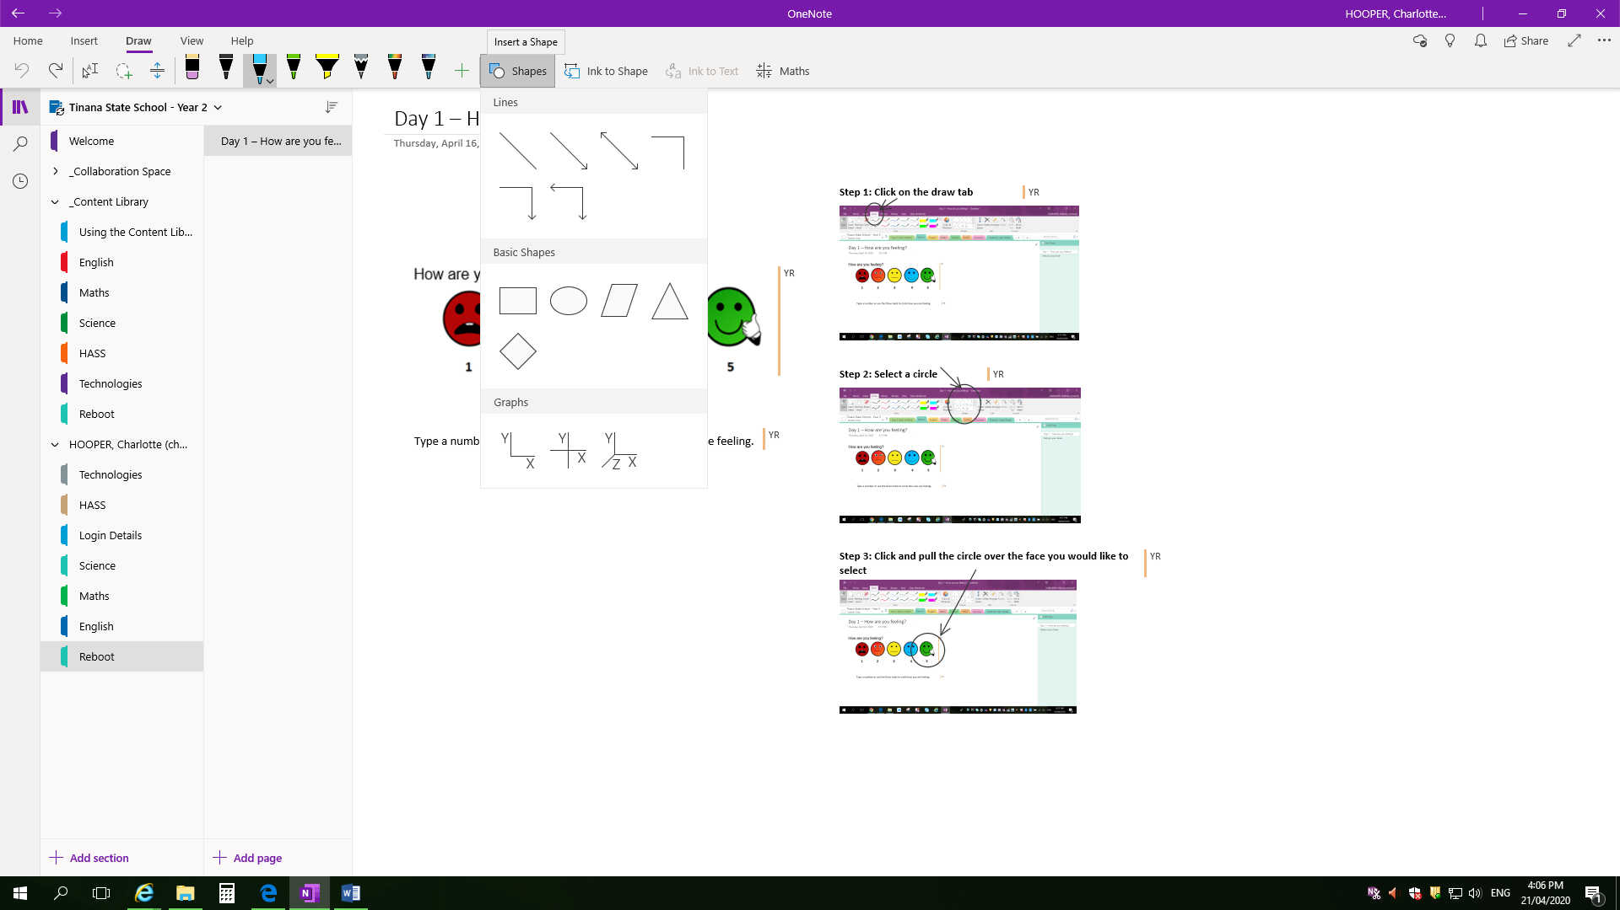
- Click and drag to make a shape (e.g. circle) | 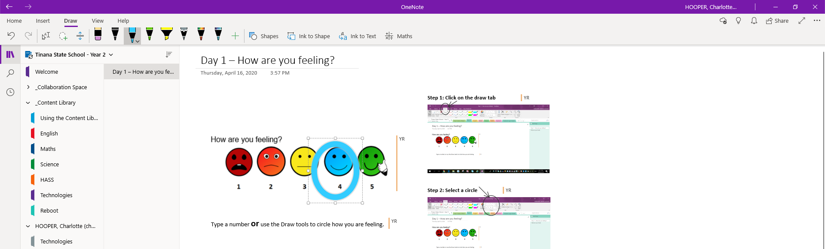
- Click here to ‘Select Objects or Type Text’
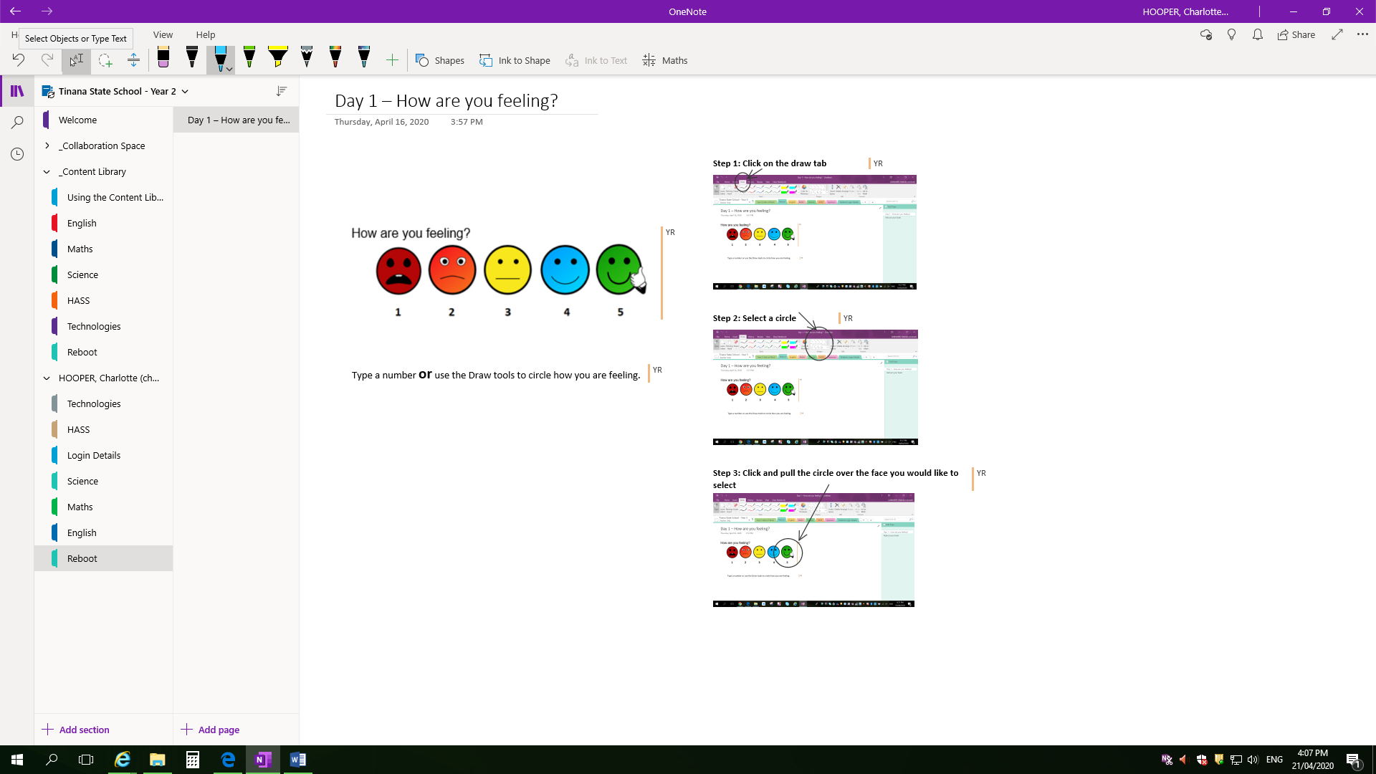
- Type text using keyboard | 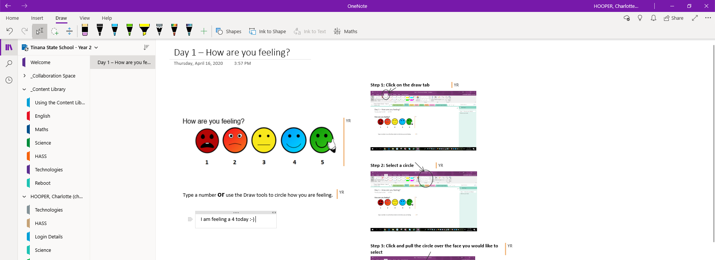
- Check ‘Page sync status’ 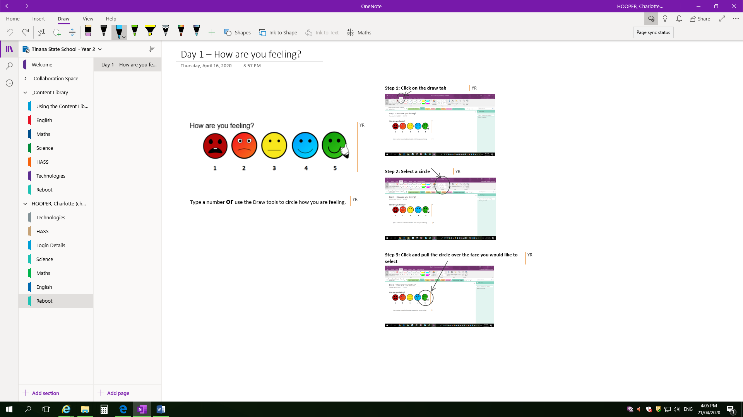
- Page saved to online successfully | 