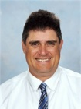  Principal BSM | Sustainability Key Teachers |  | 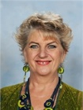  Lower School Representative Classroom Teachers
Sustainability  Captain | Literacy  Coach | Learning Support | 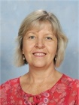  Upper School Representative  Classroom Teachers
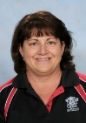 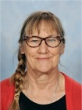  Teacher Aides Reps |  | 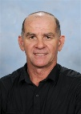  Groundsman | 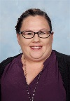  Tuckshop P&C Rep.
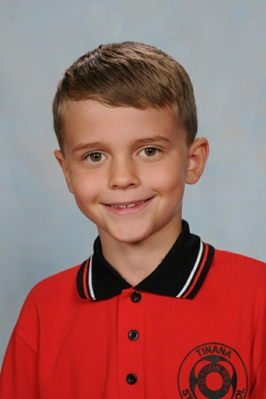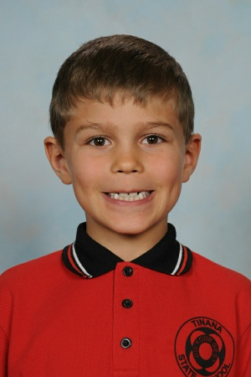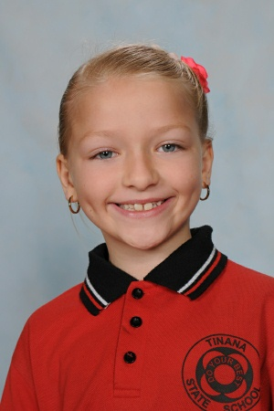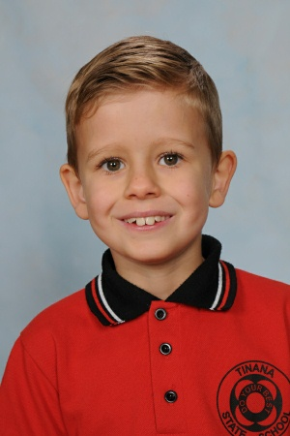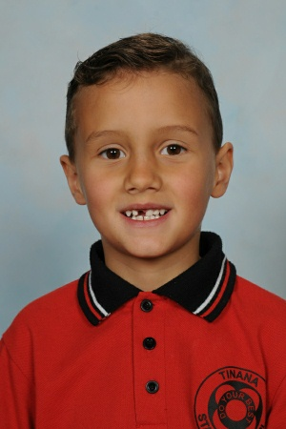
Year 3 Year 4
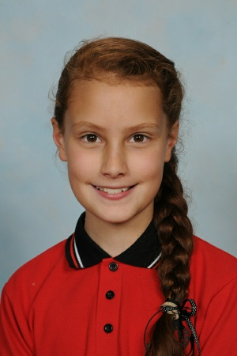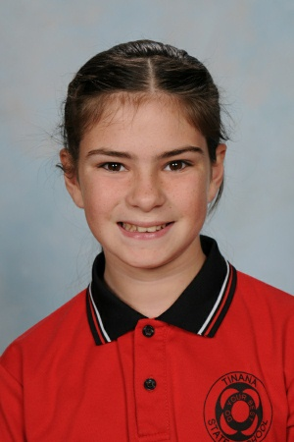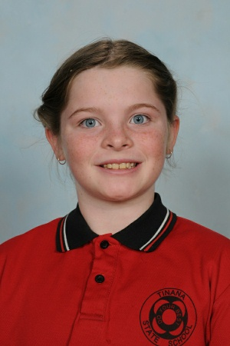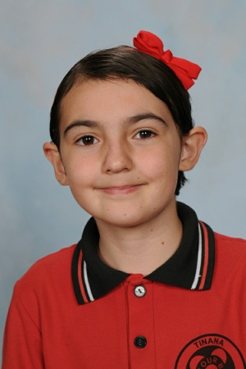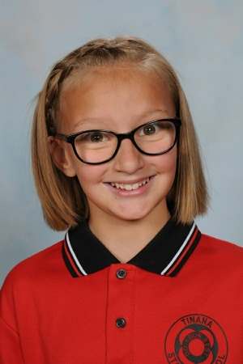
Elizabeth

Year 5 Year 6
Sustainability Class Representatives
Community Members/Partners:

* Waste Education Officer, Fraser Coast Regional Council * James Hyne – Hyne Timber * MSF Sugar
* Sue Gibson – Principal, Barambah Environmental Education Centre * Chris Yates - Aldridge SHS
* Simon Done – Principal, Maryborough SHS * Col Bowman – Butterfly Man
* Greater Mary Association * LMRCCC * FCWPSQ * MRCCC * BMRG * Lindsay Titmarsh * Glenn Miller

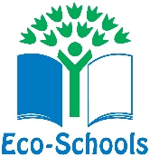
TINANA STATE SCHOOL 2019 ECO COMMITTEE
TINANA STATE SCHOOL ECO CODE
ASAP = As Sustainably As Possible
Sustainability is defined as ‘meeting the needs of the present without compromising the ability of future generations to meet their own needs’, or simply as ‘enough for all forever’.

At Tinana State School our values include:

- respect, care and compassion for ourselves, others and our environment
- responsibility for our actions
- integrity of all life on earth
- Understanding and inclusion of all peoples and perspectives.

Butchulla Laws ‘Wherever you go leave only footprints’
1. What is good for the land comes first
2. If you have plenty you must share
3. Do not touch or take anything that is not yours

Our School approach to sustainability is through:

- governance that supports sustainability policies, procedures and programs
- curriculum that is developed and delivered on the principles of environmental education for sustainability
- responsive resource management and innovation, including utilities, facilities and environs
- partnerships, alliances and networks with government, communities and business
- Implementation and evaluation of strategies and actions to reduce the school’s ecological footprint.

